File Index

Supplementary Figure 1. Pairwise correlations between epigenetic age and epigenetic age acceleration across clocks.
Supplementary Figure 2. Learning curves for LASSO, Random Forest and XGBoost models across epigenetic clocks.
Supplementary Figure 3. SHAP dependence plots for main predictors.
Supplementary Figure 4. Top predictors of gender stratified XGBoost models for GrimAge and DunedinPoAm.
Supplementary Figure 5. Top predictors of ethnicity stratified XGBoost models for GrimAge and DunedinPoAm.
Supplementary Figure 6. Top predictors of smoking stratified XGBoost models for GrimAge and DunedinPoAm.
Supplementary Figure 7. Domain-level contributions to GrimAge and DunedinPoAm prediction in gender-stratified XGBoost regression models.
Supplementary Figure 8. Domain-level contributions to GrimAge and DunedinPoAm prediction in ethnicity-stratified XGBoost regression models.
Supplementary Figure 9. Domain-level contributions to GrimAge and DunedinPoAm prediction in smoking-stratified XGBoost regression models.
Supplementary Table 2. Hyperparameter grid for Random Forest models.
Supplementary Table 3. Hyperparameter grid for XGBoost models.
List of datasets used in the study.

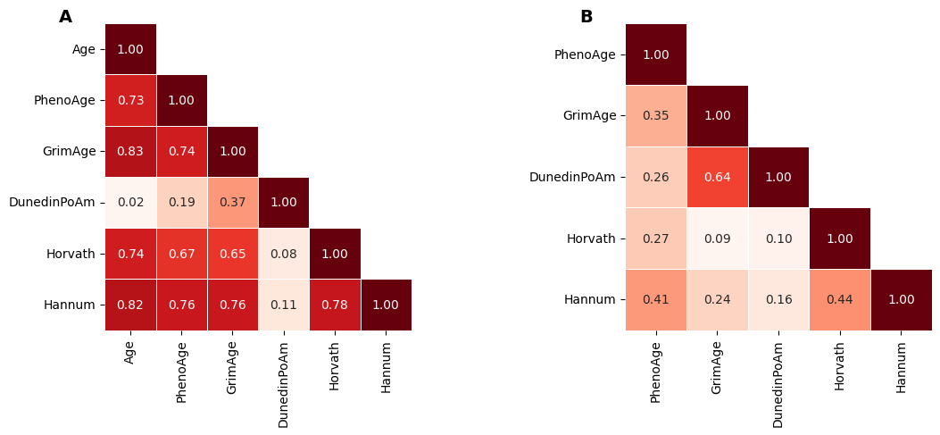
Supplementary Figure 1 Pairwise correlations between epigenetic age and epigenetic age accelerations across clocks.
(A) Pairwise Pearson correlation coefficients (r) between chronological age and DNA methylation-based age estimates (PhenoAge, GrimAge, Horvath, Hannum, and DunedinPoAm).
(B) Pairwise Pearson correlation coefficients (r) between epigenetic age acceleration (EAA) measures derived from PhenoAge, GrimAge, Horvath, and Hannum (calculated as residuals from regressing epigenetic age on chronological age), and DunedinPoAm (raw value).

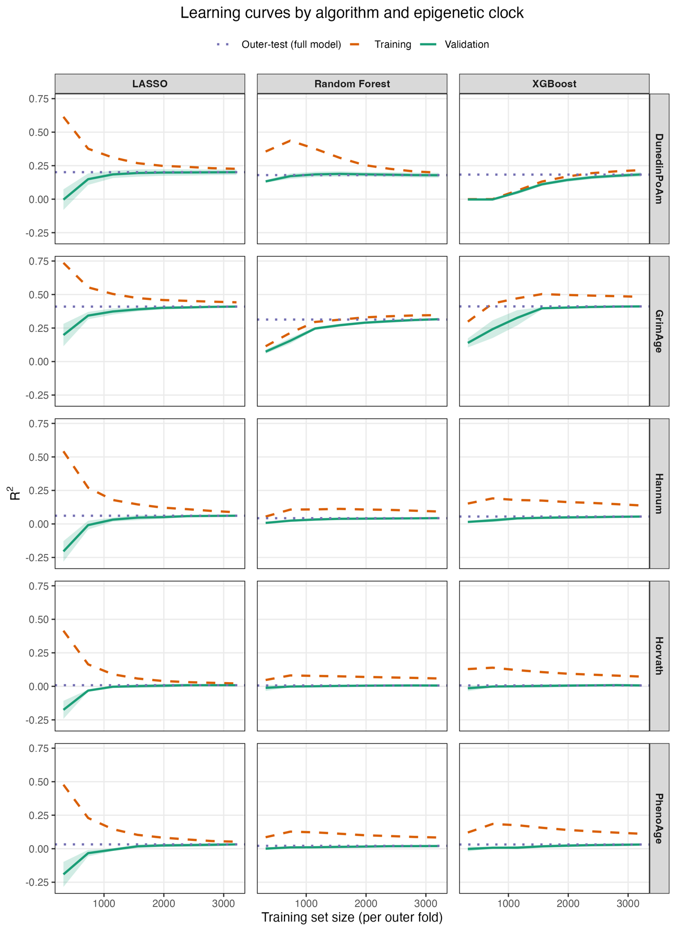
Supplementary Figure 2. Learning curves for LASSO, Random Forest and XGBoost models across epigenetic clocks. Learning curves showing R² (mean ± SD across outer folds). For each clock, models were refitted on progressively larger random subsamples of the outer-training set (x-axis: training set size per outer fold) and evaluated on the remaining training data (dashed lines) and the fixed validation fold (solid lines). Shaded ribbons represent ±1 SD across outer folds. Horizontal dotted lines indicate the corresponding outer-test R² of the full all-predictor model for each algorithm and clock.
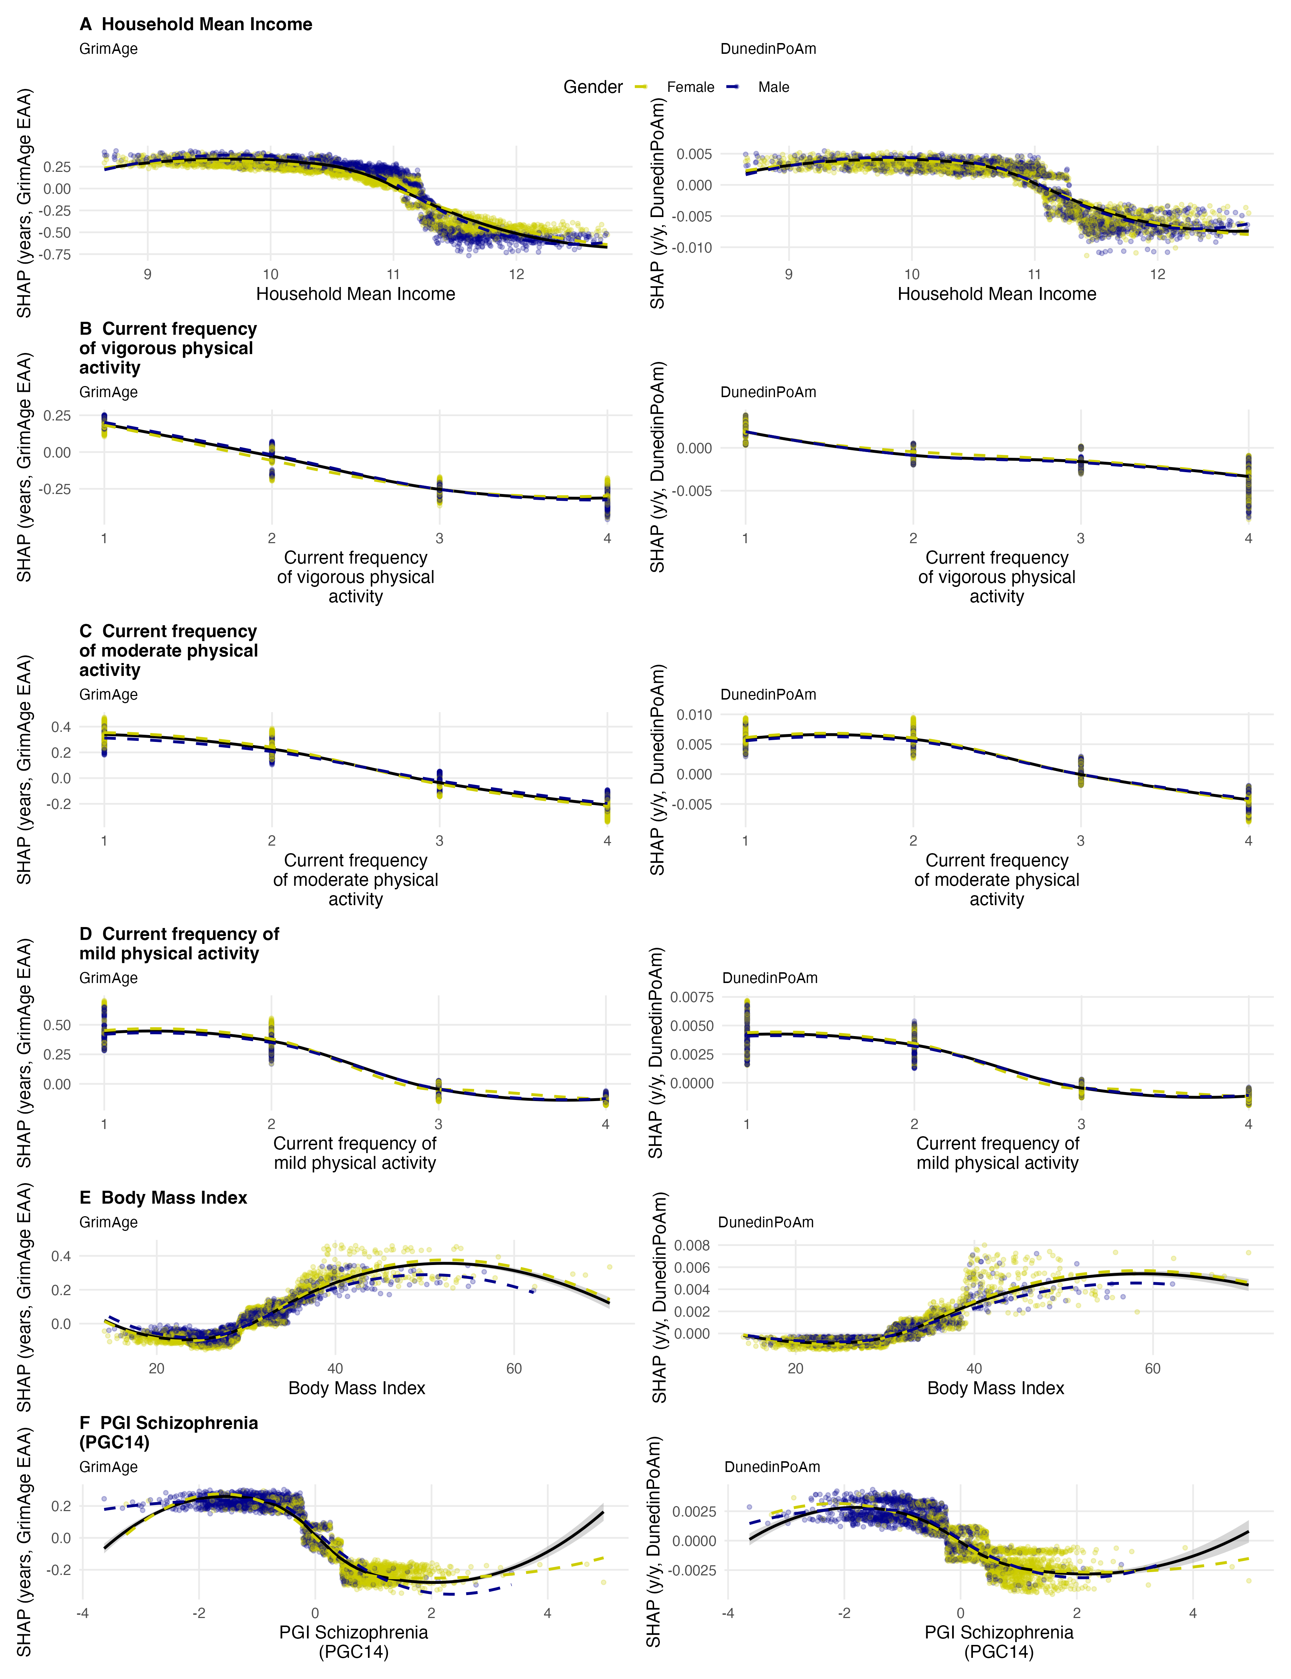
Supplementary Figure 3. SHAP dependence plots for main predictors.
Points represent out-of-sample SHAP values from XGBoost regression models including all predictors, shown for GrimAge epigenetic age acceleration (left column; years of acceleration) and DunedinPoAm pace of ageing (right column). Positive SHAP values indicate higher predicted epigenetic age acceleration or faster pace of ageing, whereas negative values indicate lower predicted acceleration or slower pace of ageing. Solid black lines, with grey 95% confidence bands, represent locally estimated scatterplot smoothing (LOESS) fits for the full sample; coloured dashed lines represent LOESS fits stratified by gender, with points coloured accordingly. Household mean income was capped at the 1st–99th percentiles and is displayed on the natural logarithmic scale.
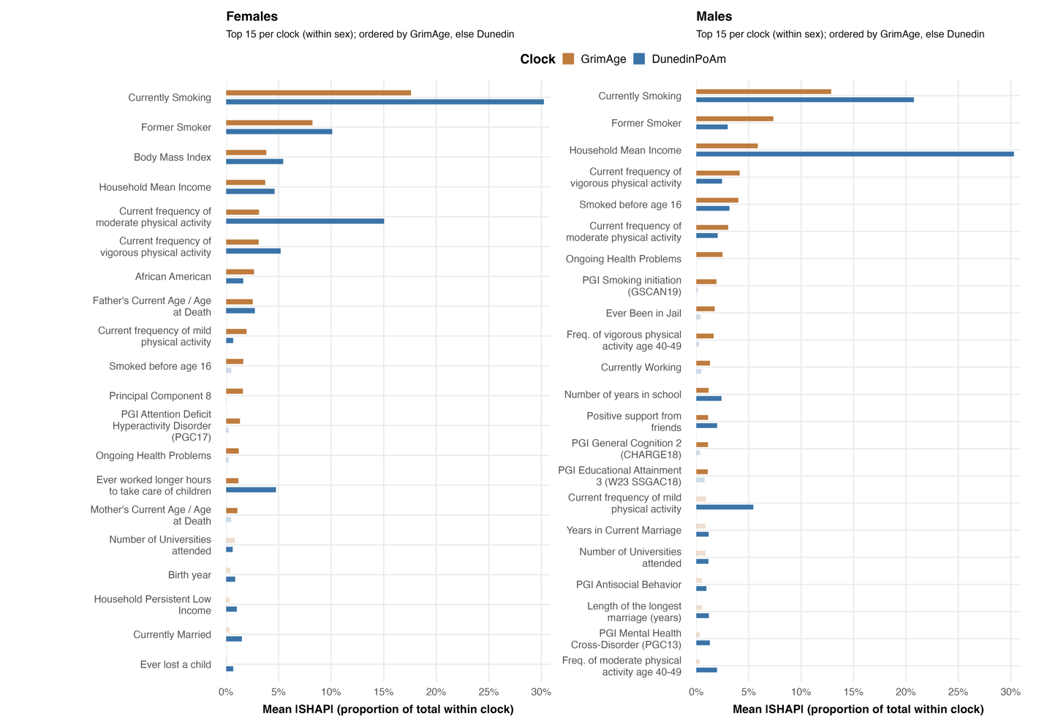
Supplementary Figure 4. Top predictors of gender stratified XGBoost models for GrimAge and DunedinPoAm.
Bars show mean absolute out-of-sample SHAP values, expressed as each variable’s proportion of total importance within clock (sums to 100% separately for GrimAge and DunedinPoAm in each gender). Within each gender, we plotted the union of the 15 most important predictors for GrimAge and for DunedinPoAm; saturated bars indicate that a predictor belongs to the top 15 for that clock, whereas faded bars indicate predictors that are only in the top 15 of the other clock. SHAP values were computed on held-out folds in the outer cross-validation and averaged across folds.
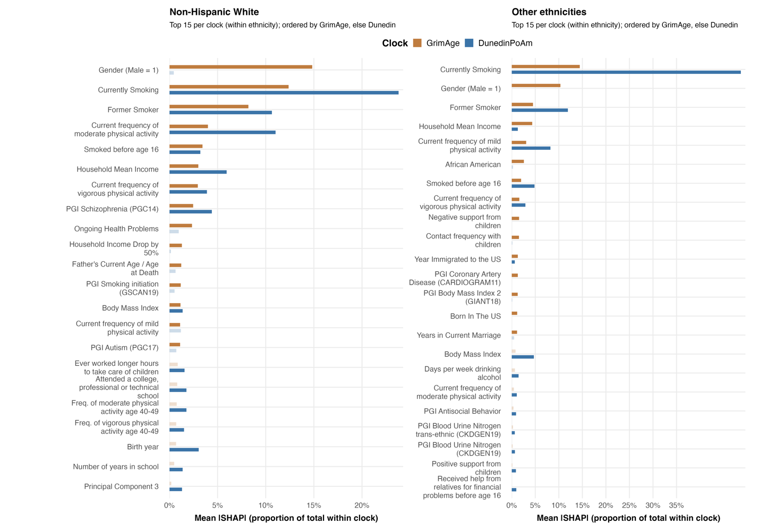
Supplementary Figure 5. Top predictors of ethnicity stratified XGBoost models for GrimAge and DunedinPoAm. Bars show mean absolute out-of-sample SHAP values, expressed as each variable’s proportion of total importance within clock (sums to 100% separately for GrimAge and DunedinPoAm in each stratum). Within each stratum (white and non-white), we plotted the union of the 15 most important predictors for GrimAge and for DunedinPoAm; saturated bars indicate that a predictor belongs to the top 15 for that clock, whereas faded bars indicate predictors that are only in the top 15 of the other clock. SHAP values were computed on held-out folds in the outer cross-validation and averaged across folds.

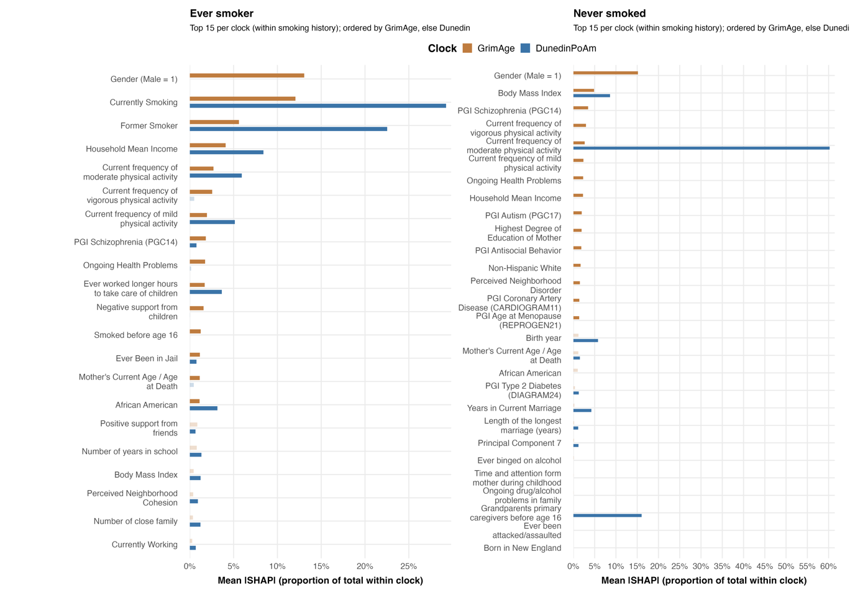
Supplementary Figure 6. Top predictors of smoking-history stratified XGBoost models for GrimAge and DunedinPoAm.
Bars show mean absolute out-of-sample SHAP values, expressed as each variable’s proportion of total importance within clock (sums to 100% separately for GrimAge and DunedinPoAm in each gender). Within each gender, we plotted the union of the 15 most important predictors for GrimAge and for DunedinPoAm; saturated bars indicate that a predictor belongs to the top 15 for that clock, whereas faded bars indicate predictors that are only in the top 15 of the other clock. SHAP values were computed on held-out folds in the outer cross-validation and averaged across folds.

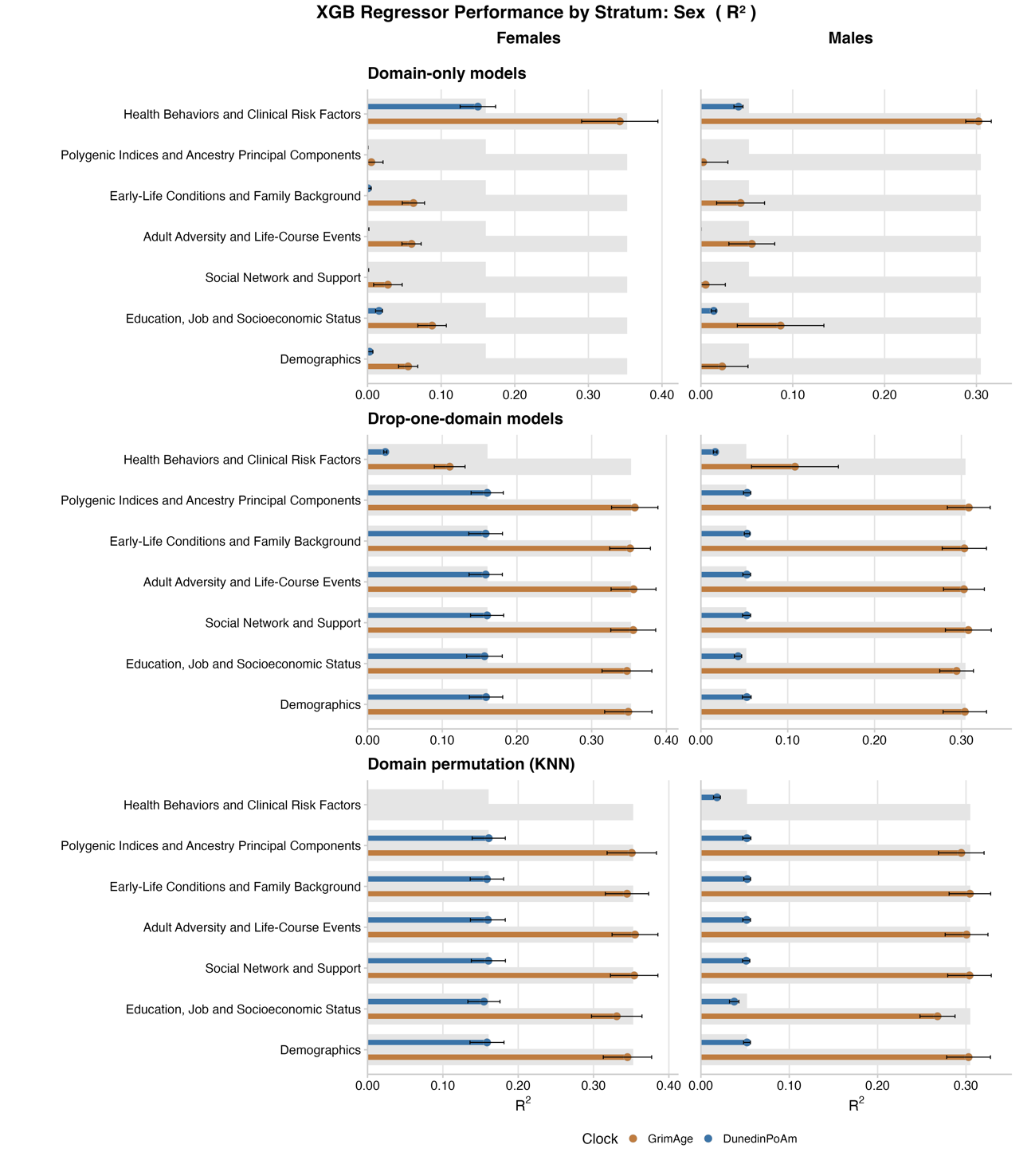
Supplementary Figure 7. Domain-level contributions to GrimAge and DunedinPoAm prediction in gender-stratified XGBoost regression models.
Each panel shows out-of-sample R² (mean ± SD across outer folds) for GrimAge (orange) and DunedinPoAm (blue) when information from different conceptual domains is varied for males and females. Wide grey bars indicate the performance of the full all-predictor model for each clock. In the Domain-only models panel (top), coloured bars represent models fitted using only the variables from a single domain. In the Drop-one-domain models panel (middle), coloured bars represent performance when all variables from the corresponding domain are removed from the full model. In the Domain permutation (KNN) panel (bottom), coloured bars show performance after jointly permuting all variables within each domain among the 40 nearest neighbours defined on the remaining predictors (KNN conditional permutation).

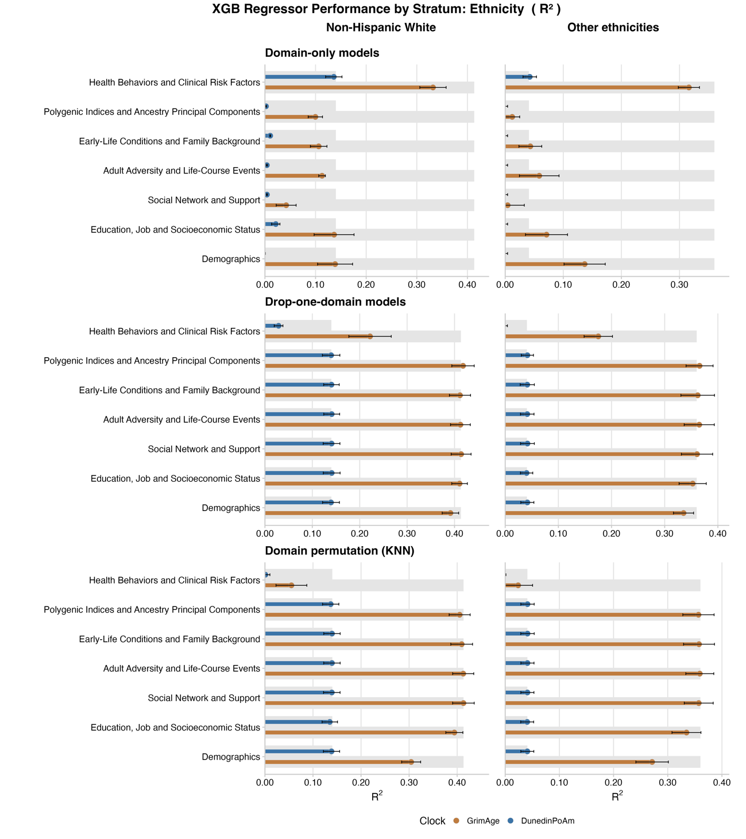
Supplementary Figure 8. Domain-level contributions to GrimAge and DunedinPoAm prediction in ethnicity-stratified XGBoost regression models.
Each panel shows out-of-sample R² (mean ± SD across outer folds) for GrimAge (orange) and DunedinPoAm (blue) when information from different conceptual domains is varied for non-Hispanic White individuals and participants of other ethnicities (Hispanics, African-American and other). Wide grey bars indicate the performance of the full all-predictor model for each clock. In the Domain-only models panel (top), coloured bars represent models fitted using only the variables from a single domain. In the Drop-one-domain models panel (middle), coloured bars represent performance when all variables from the corresponding domain are removed from the full model. In the Domain permutation (KNN) panel (bottom), coloured bars show performance after jointly permuting all variables within each domain among the 40 nearest neighbours defined on the remaining predictors (KNN conditional permutation).

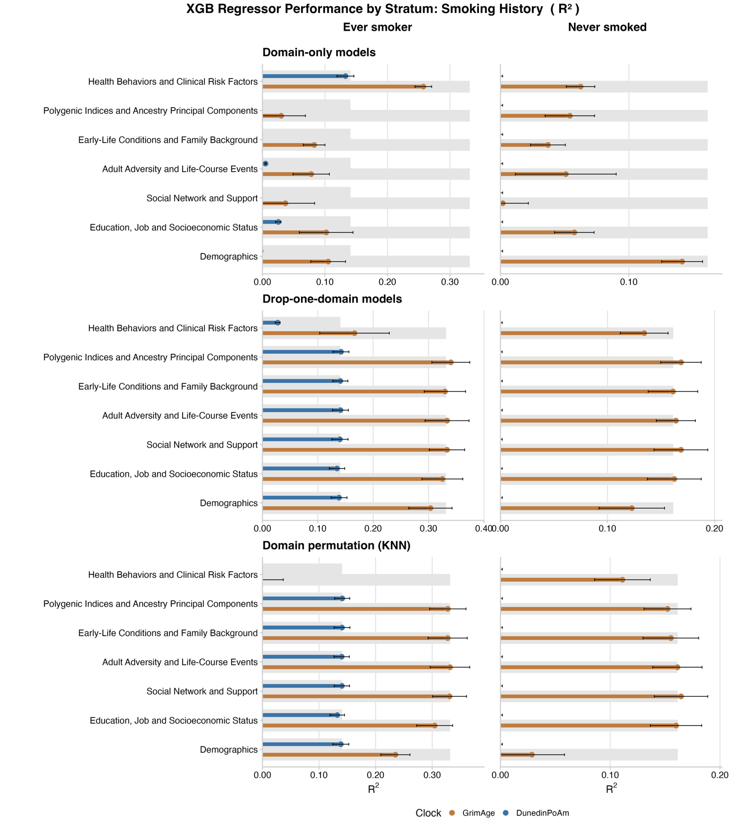
Supplementary Figure 9. Domain-level contributions to GrimAge and DunedinPoAm prediction in smoking-stratified XGBoost regression models.
Each panel shows out-of-sample R² (mean ± SD across outer folds) for GrimAge (orange) and DunedinPoAm (blue) when information from different conceptual domains is varied for ever-smokers and never-smokers. Wide grey bars indicate the performance of the full all-predictor model for each clock. In the Domain-only models panel (top), coloured bars represent models fitted using only the variables from a single domain. In the Drop-one-domain models panel (middle), coloured bars represent performance when all variables from the corresponding domain are removed from the full model. In the Domain permutation (KNN) panel (bottom), coloured bars show performance after jointly permuting all variables within each domain among the 40 nearest neighbours defined on the remaining predictors (KNN conditional permutation).

Table S2. Hyperparameter grid for Random Forest models.
 | GrimAge, Horvath, Hannum, PhenoAge | DunedinPoAm
Number of Estimators | 300, 600, 900 | 600, 900, 1200
Max depth | 3, 4, 5 | 6, 8, None
Min Samples Split | 40, 80, 120 | 10, 20, 40
Min Samples Leaf | 20, 40, 80 | 5, 10, 20
Max Features | Log2, 0.1, 0.2 | Sqrt, 0.5
Max Samples | 0.4, 0.5, 0.6 | 0.6, 0.8, 1.0
Cpp Alpha | 0.0005, 0.0015, 0.003 | 0.0, 0.005, 0.001
Min impurity decrease | 1×10⁻⁴, 5×10⁻⁴, 1×10⁻³ | 0.0, 1×10⁻⁴, 5×10⁻⁴

Table S3. Hyperparameter grids for XGBoost models.
 | GrimAge, Horvath, Hannum, PhenoAge | DunedinPoAm
Number of Estimators | 600, 900, 1200 | 800, 1200, 1600
Learning Rate | 0.01, 0.02 | 0.03, 0.05
Max Depth | 2, 3 | 2, 3
Min Child Weight | 30, 60, 90 | 20, 40, 80
Subsample | 0.5, 0.6 | 0.6, 0.8
Colsample by Tree | 0.5, 0.6 | 0.6, 0.8
Colsample by Level | 0.6, 0.8 | 0.6, 0.8
Gamma | 5, 10, 15 | 0, 1, 3, 5
Reg Lambda | 100, 200, 300 | 60, 120, 200, 300
Reg Alpha | 10, 20, 40 | 10, 30, 60

List of datasets used in the study

Health and Retirement Study (2025). Cross-wave 2015-2019 Life History Mail Survey (LHMS): Harmonized and Aggregated Public Data Resource (V1.0) [Data set]. Produced and distributed by the University of Michigan with funding from the National Institute on Aging (grant number NIA U01AG009740). https://doi.org/10.7826/XUFS7190
Health and Retirement Study (2020). Cross-Wave Childhood Health And Family Aggregated Data (V2.0) [Data set]. Produced and distributed by the University of Michigan with funding from the National Institute on Aging (grant number NIA U01AG009740). https://doi.org/10.7826/KSPN3634
Health and Retirement Study (2024). Cross-wave Lifecourse Experiences of Adversity and Trauma Aggregated Data (Version 1.0) [Data set]. Produced and distributed by the University of Michigan with funding from the National Institute on Aging (grant number NIA U01AG009740). https://doi.org/10.7826/AFUA5287
Health and Retirement Study (2025). Cross-Wave Tracker File (Final 2022 V1.0) [Data set]. Produced and distributed by the University of Michigan with funding from the National Institute on Aging (grant number NIA U01AG009740). https://doi.org/10.7826/OZGE2932
Health and Retirement Study (2021). 2006 HRS Core (Final V4.0) [Data set]. Produced and distributed by the University of Michigan with funding from the National Institute on Aging (grant number NIA U01AG009740). https://doi.org/10.7826/FSDG9739
Health and Retirement Study (2014). 2008 HRS Core (Final V3.0) [Data set]. Produced and distributed by the University of Michigan with funding from the National Institute on Aging (grant number NIA U01AG009740). https://doi.org/10.7826/RUVG6753
Health and Retirement Study (2021). 2010 HRS Core (Final V6.0) [Data set]. Produced and distributed by the University of Michigan with funding from the National Institute on Aging (grant number NIA U01AG009740). https://doi.org/10.7826/PVIY7805
Health and Retirement Study (2020). 2012 HRS Core (Final V3.0) [Data set]. Produced and distributed by the University of Michigan with funding from the National Institute on Aging (grant number NIA U01AG009740). https://doi.org/10.7826/YRMA2094
Health and Retirement Study (2017). 2014 HRS Core (Final V2.0) [Data set]. Produced and distributed by the University of Michigan with funding from the National Institute on Aging (grant number NIA U01AG009740). https://doi.org/10.7826/UPFY7910
Health and Retirement Study (2019). 2016 HRS Core (Final V2.0) [Data set]. Produced and distributed by the University of Michigan with funding from the National Institute on Aging (grant number NIA U01AG009740). https://doi.org/10.7826/BNXV5753
Health and Retirement Study, RAND HRS Longitudinal File 2016 (V2) public use dataset. Produced and distributed by the University of Michigan with funding from the National Institute on Aging (grant number NIA U01AG009740). Ann Arbor, MI, (2020).
RAND HRS Longitudinal File 2016 (V2). Produced by the RAND Center for the Study of Aging, with funding from the National Institute on Aging (grant numbers NIA U01AG009740 and NIA R01AG073289) and the Social Security Administration. Santa Monica, CA (April 2020).
Health and Retirement Study (2020). HRS Epigenetic Clocks (v1.0) [Data set]. Produced and distributed by the University of Michigan with funding from the National Institute on Aging (grant number NIA U01AG009740). https://doi.org/10.7826/LPIK1762
Health and Retirement Study (2024). Polygenic Score Data (PGS) (V5) [Data set]. Produced and distributed by the University of Michigan with funding from the National Institute on Aging (grant number NIA U01AG009740). https://doi.org/10.7826/JZEL8053

